DETERMINING THE ATTITUDE AND ROTATION RATE OF
Atmospheric Neutral Density Experiment
January 5th 2007-February 12th 2007
Midshipmen 1/c Okun and Smythe,
Faculty: Bob Bruninga, PE
US Naval Academy Satellite Lab

INTRODUCTION (rev b) 3 May 07

Revision B updates this report with data through May 07.

On 21 December 2007, ANDE was deployed from the ISS. The deployment however, did not proceed as expected. The ANDE MAA spacecraft appeared to be stuck in the deployment can, but was later confirmed to have separated after about 30 minutes. Although, it was fully operational, the anomalous deploy did not achieve the desired 5 RPM initial spin rate. Two clips from the video of separation are shown below. Visually we determined that the “can” rotated approximately sixty degrees in thirty seconds. This would indicate the initial spin of the spacecraft inside could not have been greater than .17 RPM.
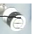
By analyzing the telemetry sent from ANDE, an effort has been made to determine the attitude and rotation rate of the spacecraft using the six orthogonal sun sensors as shown in figure 1. The positive X,Y, and Z are repeated in ANDE MAA side A telemetry and the negative X,Y and Z are repeated in Side B telemetry.

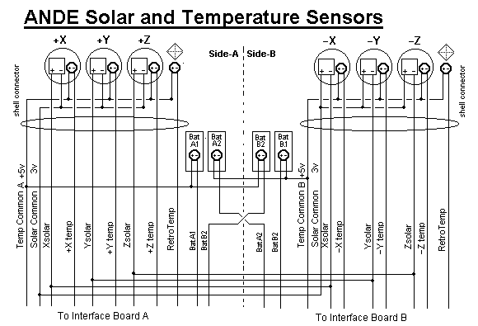
Figure 1: ANDE Sensors.
SUN SENSORS

These sensors consist of a one inch diameter silicon cell with an output voltage of .55 volts open circuit as shown in figure 2. These cells are connected to individual three ohm resistor loads and the resulting output voltages are proportional to the solar current. These in turn are proportional to the cosines of the sun angles. By examining the six solar panels’ (+X,+Y,+Z, -X,-Y,-Z) solar current telemetry, the angle to the sun could be determined.

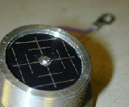
Figure 2: Solar sensor

PRE-LAUNCH INTEGRATION ISSUES:

Early integration testing revealed that the solar sensors had been manufactured with the positive lead grounded. Since the Telemetry system was based on a negative ground reference with only 0-5v positive input values, the circuits were incompatible. Since the cells were already manufactured, the only place to correct for this discrepancy was in the telemetry system. To correct for this problem, two diode voltage drops were added to offset the solar cell output upward into the positive range by 1 volt as shown in figure 3.
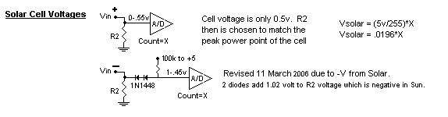
Figure 3: Solar Cell Telemetry System

Since the solar cell output voltage was determined to be a negative -0.5V at a maximum in sun, the telemetry input was offset by 1 volt (two diode voltage drops) so that these negative values would still be above zero. Since the diodes raise the voltage by 1.02 volts, this offset yields a positive value for telemetry under a maximum sun exposure. Although this solved the negative telemetry issue, the diodes introduced a slight temperature dependency in the sun sensor –current- telemetry channels.

However, as will be shown by the data, much of the telemetry from the solar panels was unreliable. Fortunately each sensor location also had a temperature thermistor and by examining the change in temperature of the sensors one could get an indication of which portion of the spacecraft was in the sun over a given time. This in combination with the useable solar panel data were examined for the spin determination.

SOLAR SENSOR TELEMETRY

Telemetry packets from ANDE volunteer ground stations around the world were captured each day using the Alogger program. Although this system provides convenient, automatic, and consistent data, these data sets are not continuous due to the sparse location of the ground stations and the lack of these stations in many parts of the world. This under-sampling requires cogent assessment and interpretation of the data. For example, on days when only USNA data was available and the precession of the orbit had all passes in the nighttime (mid January) at USNA, an uniformed reading of the solar sensor data would conclude ANDE was not in the sun at all for that day when this simply is not possible. For this reason, analysis focused on passes when long data sets were available in the sun from one ground station.

Twenty seven days of data starting on 1 Jan2007 were used for the initial analysis. For each day, the solar current and temperature telemetry was assessed and placed into a user friendly excel format. For each packet, the UTC, local time, and location of the contacting site were identified. By knowing the local time over a given location, it gave an indication of how the sun was situated at that point in time for assistance in the attitude determination.

TELEMETRY FORMAT:

Telemetry for each side of the spacecraft is in four frames. The solar data was in the eleventh frame counter, with the second, third, and fourth channels being the data for the X, Y, and Z panel respectively. Any time the telemetry was less than 48 on a given channel, that panel was in the sun.

The temperature telemetry data was obtained from frames that began with 10. The first channel corresponded to the battery temperature. The second third and fourth represented the solar panel temperature of the X, Y, Z panels. The fifth channel was used for the retro reflector temperature. The temperature telemetry was converted to degrees Celsius using the following equation:

Temp(C) = .00001 * X ^ 3 - .0039 * X ^ 2 + .829 * X - 40.4
Temperature conversion equation

The telemetry channels can be summarized below.

FF CHANNEL 1 CHANNEL 2 CHANNEL 3 CHANNEL 4 CHANNEL 5
-- ----------- ---------- ---------- ---------- ----------
11 BUS-Volts SOLAR-X SOLAR-Y SOLAR-Z 5V BUS
10 Temp-BAT Temp-SOL-X Temp-SOL-Y Temp-SOL-Z Temp-Retro
01 Laser-Volts A1-Amps A2-Amps B1-Amps B2-Amps
00 Temp-Bat-B Clock Temp-Laser Time-to-Go On-Time

ANALYSIS

The first conclusion made on the 27 day data concerned the solar sensors for the positive and negative Y and Z face. Initially, these solar sensors gave data indicating that the faces were not in the sun for days at a time. However, the baseline data was not flat either. And temperature data for these same sensors for the faces indicated varying temperatures. For this reason we could not early on declare that the sensors were not functioning correctly from this 27 days of data.

The temperature changes observed in that data could have been a result of thermal diffusion through the spacecraft. Considering that the temperature changes varied as much as thirty degrees on these faces but very little change occurred in the output of the solar sensors, the conclusion was that any change in solar readings for the Y and Z face solar sensors was due to a temperature change and not do to solar incidence. This was seen on the B side sensors for January 24th. At 9 AM, a pass occurred over USNA in which the X temperature increased by 3 degrees in 5 minutes but the solar sensor indicated no change in sun.

Later on, however, at the four month point, the failure of all six sun sensors is clearly conclusive as shown in the next two plots. The first plot shows the +X, +Y and +Z sensors and how the Y axis was known failed before launch, the +Z failed within the first week and the +X failed after about a month. Ignore the off-scale telemetry garble on 12 March.
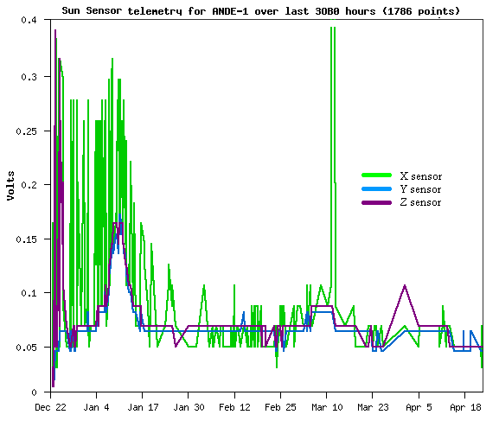
Figure 4. A side +X, +Y and +Z Sun Current Sensor data

The next plot shows how all three –X, -Y and the –Z sensors were all failed by the time of initial operation. The only variation was from the secondary temperature coefficient of the telemetry system as noted before. To cleary show the temperature dependency, compare these trend lines with the plot of core temperature over the same 4 month time later in this report.

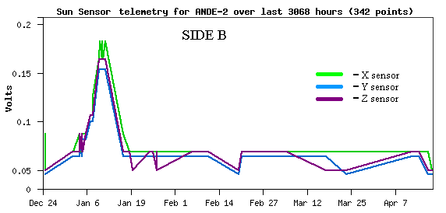
Figure 5. ANDE MAA Side B Sun Current Sensor data

SENSOR BASELINE

Prior to launch during March 2, 2006 integration testing, the +Y sensor was found to be an open circuit. Since there were no spares, the Y sensor was flown anyway. Therefore, this current telemetry would appear identical to a dark sensor on orbit. Comparing this failed +Y sensor reading to the baseline dark readings of all the other sensors, and then comparing to the baseline core temperature of the spacecraft as shown in figure 6, gives a very high correlation of dark current values with a significant temperature coefficient. Furthermore, since we know the Y sensor was an open circuit, this temperature variation is not a function of the solar cell, but of the telemetry system itself.
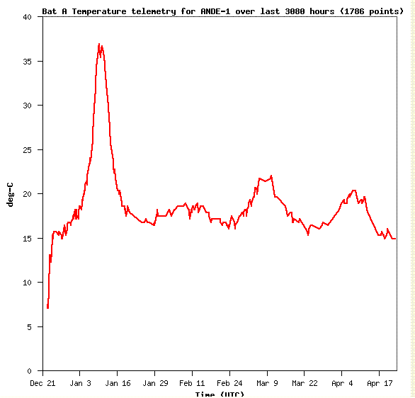
Figure 6. ANDE MAA Core Temperature Profile

As noted before, this dependency was traced to the two diodes that were added to the telemetry system to compensate for the positive-sided-ground of the sun sensors. The temperature coefficient for the silicon diodes is -2 mv/K. This temperature effect offset in the data is clearly evident. The voltage for a sensor had previously been determined using the equation V=1-.019*telemetry. Now that the temperature effect has been determined the new equation is Solar Voltage = 1 - .019 * [X + 9.48 - .0741 * BT], where X is the telemetry count for that sun sensor and BT is the battery temperature.

Furthermore, the Y sensor was consistently 3 units greater than the X sensor for both the A and B side. For example when the Y sensor reads 47 the X reads 44, and when the Y reads 52 the X reads 49. This suggests that the individual sensors also have a small offset bias.

TEMPERATURE OBSERVATIONS OF SPIN

The lack of reliable sun sensor currents, the sparseness of ground station sampling, and the orbit phase which placed orbit passes over the northern hemisphere in the dark for much of this analysis period, a better method of analysis came from the temperature data. By examining the changes in temperature and the operating solar panel data certain conclusions were drawn about the rotation rate about ANDE. Using MATLAB, we imported the temperature data from the X-panel 24 JAN 07 and plotted the data points with respect to time. Using the curve fitting toolbox, we then fit a sinusoid to the data, as shown in the figure. The fit, shown in figure 4, indicated that the face could have rotated into and out of the sun with a period of approximately 6 minutes which is .167 RPMs.

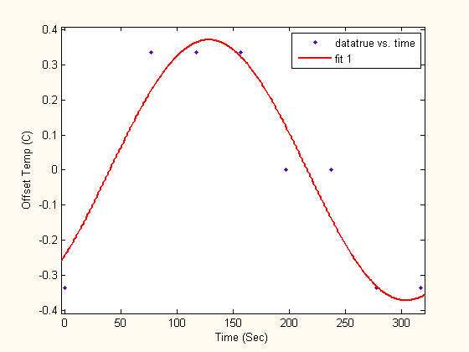

Figure 7: ANDE RPM

The data used to form this conclusion was one of the longest consistent data sets over a ground station in the 27 day data, and seemed to offer the most potential for analysis. However, other data sets were examined and supported this approach.

THERMAL DESIGN

Although the purpose of this analysis was to determine the rotation rate and attitude of the satellite, other valuable thermal information came from the data. Over the twenty seven days, the maximum temperature a panel ever achieved was 45.8 degrees for the +X panel on the 9th of January. The lowest temperature for the +X panel was 1.5 degrees on the 15th of January. These dates shown below in Figure 8, also correspond with the minimum and maximum eclipse times of ANDE.

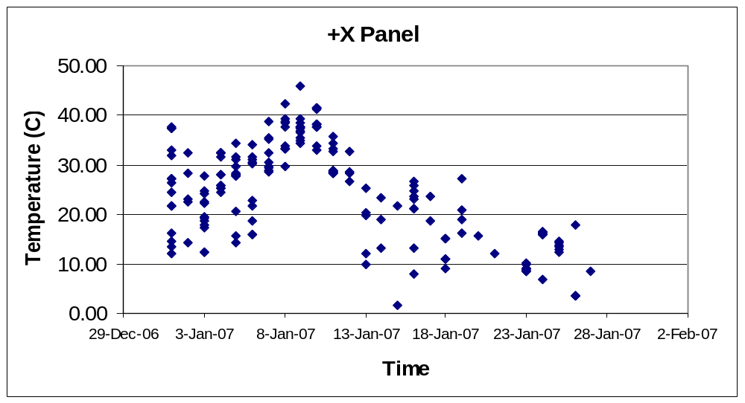

Figure 8: +X Sensor Temperature

Around January 9th, ANDE’s orbit was almost identical to the ground track of the sun in the Northern Hemisphere giving nearly constant sun. Due to the precession of the orbit, by January 15th, ANDE was nearly back into maximum eclipse periods. These extremes support the thermal design baseline of ANDE MAA and possible future ANDE satellites. The satellite can expect to see over forty degrees of long term temperature variation. Whereas the orbit-by-orbit variation of the core is practically nil (under 2 degrees max).

The plot above not only shows the long term temperature variation due to orbit sun angle, it also shows the single orbit fluctuations of the shell temperature as well as over each day.

In contrast, the internal battery temperature over the course of the same data collection was also graphed. It easily shows the consistent average internal core temperature variations drastically moderated compared to the high orbit fluctuations of the outside shell temperatures as can be seen in figure 9.

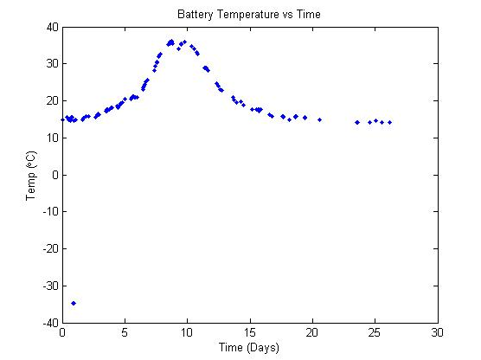
Figure 9: Battery Temperature

In comparison, the range of shell temperature fluctuations with the relatively unchanging battery temperature, any missing data due to the sparse distribution of ground stations can be observed.

It should also be noted that the first day of data collecting was also a maximum eclipse period and saw the largest one day change in temperature for the solar panel. The maximum temperature achieved on the 1st was 37.3 degrees with a minimum on that day of 12.1 degrees. These temperatures show the single orbit ninety minute temperature change as high as twenty five degrees. Figure 6 showed a much longer trend of the core temperature for the first 4 months of data. We have only seen one full sun period to date.

LASER RANGING DATA:

On 16 April 2007, laser ranging data was taken from Graz, Austria as shown below in Figure 10. The data shows 5 corner reflectors coming into and out of view over a 4 minute period. The spacing between three of them appear about the same, with the separation between the 3rd and 4th about 36% longer. Mechanical data on the ANDE MAA sphere indicates that the separation of the corner reflectors ranged between a minimum of 5.9 inches and a maximum of 10.6 inches. But this 36% longer separation matches pretty well the spacing difference between the 6.2 and 8.4 inch spacings.

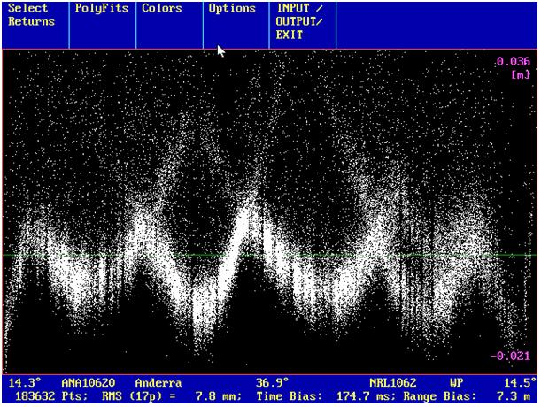
Figure 10. Laser Ranging Data from Graz, Austria (Kirchner)

Using these figures, and the 60” circumference, then the spacecraft rotated about 6.2 inches in .8 minutes or about 0.13 RPM relative to the observing station. However, during such a four minute pass, the aspect angle to the spacecraft also changed in azimuth by about 135 degrees or about .375 revolution in 4 minutes. This is about 0.09 RPM which is either added to or subtracted from the actual spacecraft RPM to get the observed RPM of 0.13.

As a result, depending on the direction of spin posigrade or retrograde, the actual spacecraft rotation rate would appear to be bounded on the upper end by 0.22 and on the lower end of 0.04 RPM. We would assume the latter, since it is doubtful that ANDE MAA could actually speed up its spin in orbit above the initial observation of 0.17, and would more likely slow down due to the internal liquid electrolyte absorbing spin energy.

CONCLUSIONS

Several conclusions were drawn from this analysis.

- All Sun current-sensors appear to have become inoperative either prior to deployment, or soon after exposure to space.

- The diode offset added to correct for the postivive-grounded solar sensors added an unintended temperature bias to the telemetry for those sensors. But this could be subtracted out in the display equations and was not an issue.

- An initial general rotation rate upper bound of about .17 RPM was determined by video observation and another 0.17 RPM rotation rate was gleaned from thermal data even though the solar sensors were not functioning. It was an independent coincidence that these two spin rates exactly matched over the intervening 27 days.

- The equivalence of these two identical readings is purely a coincidence. We make no suggestion that there has been no change in RPM. This is physically impossible since the ANDE MAA is full of 112 Lithium Battery cells that have free-liquid electrolyte sloshing around. We would assume that such free liquid would absorb and dissipate out any long term spin energy.

- Laser Ranging data at about the 4 month mission elapsed time appears to show a 0.04 RPM observable spin rate over Graz Austria on 16 April 2007.

- The telemetry data gave good feedback to the ANDE MAA thermal design. Shell temperatures fluctuate by about 20 to 25 degrees per orbit. The core temperatures change on the order of 1 degree or so per orbit.

- The maximum and minimum shell temperature extremes have been about 45C and 0 deg C.

- Seasonal fluctuation of ANDE MAA temperatures due to eclipse cycles from full sun to maximum eclipses vary the core temperature over about 20 degrees maximum and more typically 5 to 10 degrees. Maximum core temperature has been 37C and minimum has been about 15 C.

